**Turing Machine Intro and Basics**

**Accepting Device**

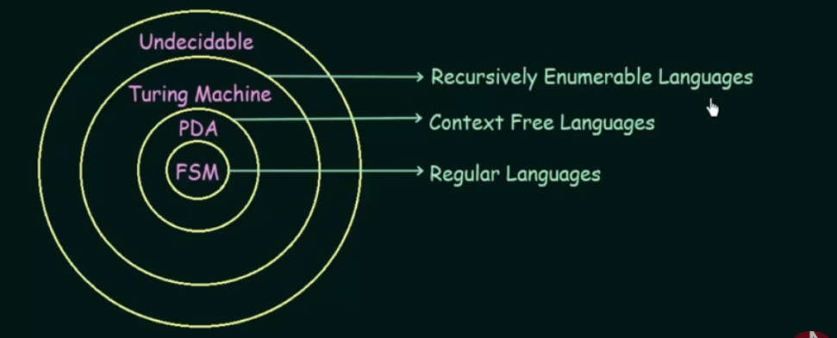

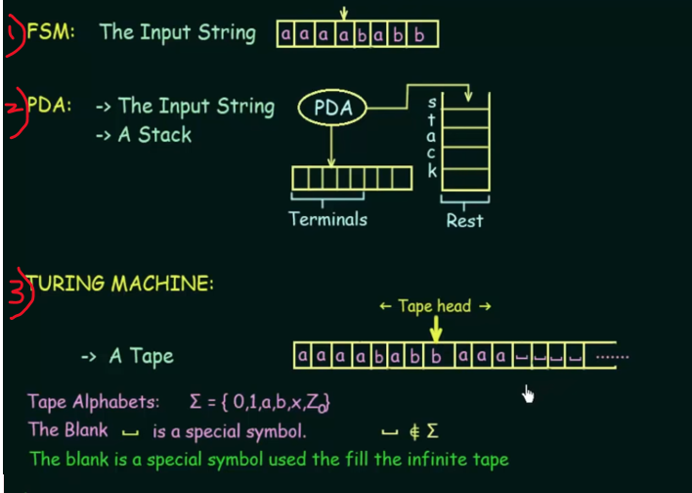

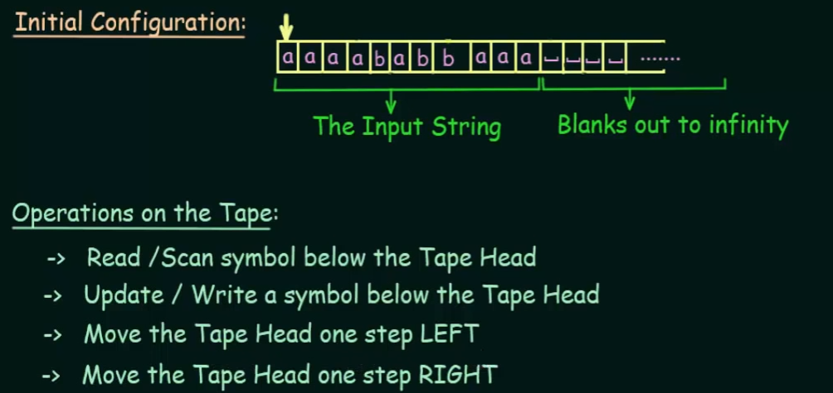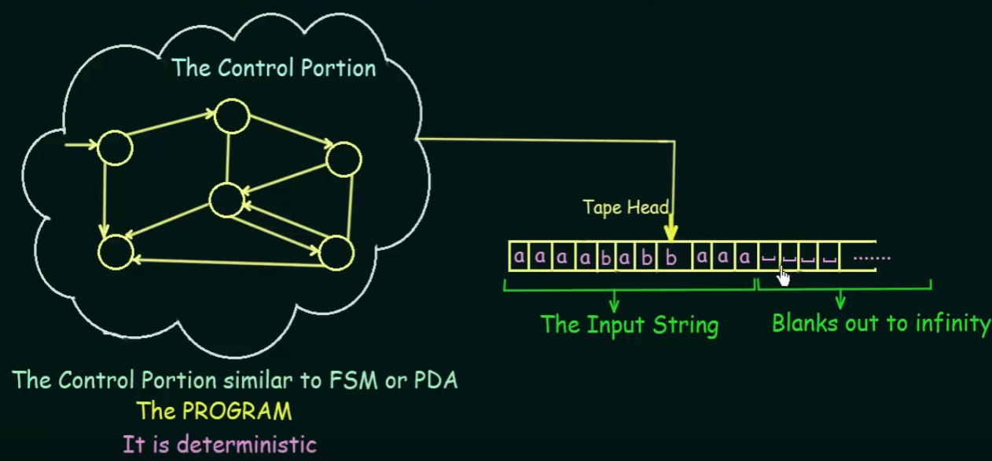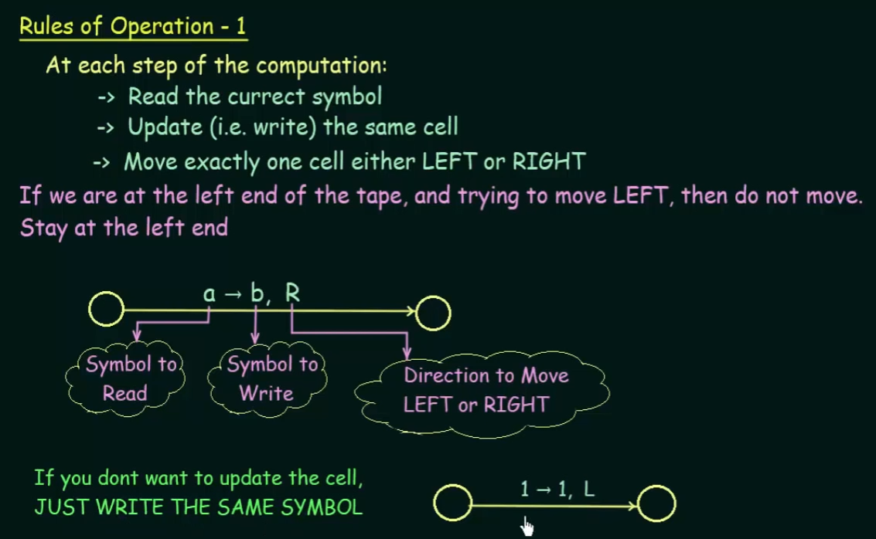

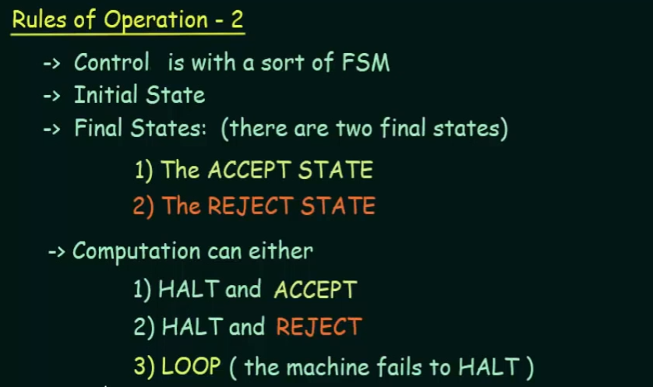

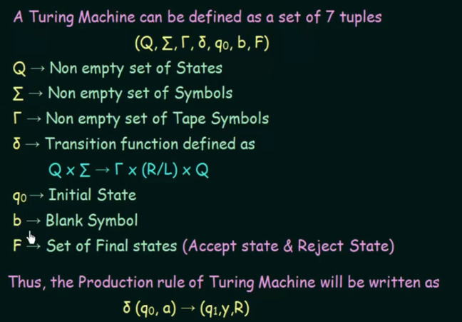

Read the input symbol **a** and write into the tape as **Y** and move to the **right.**

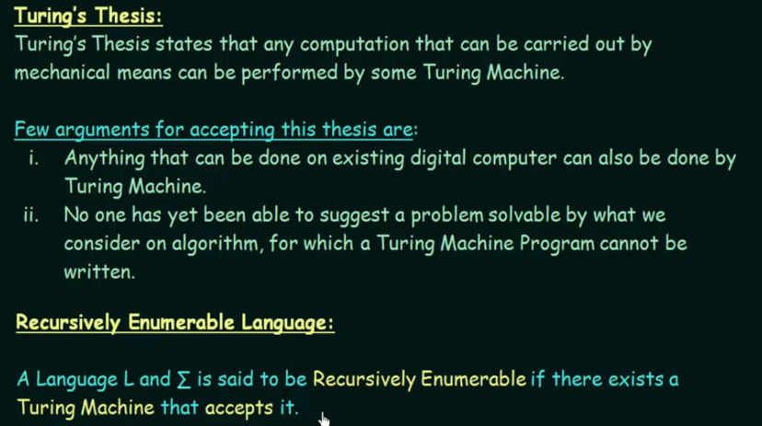

If I have a problem and I designed an algorithm to solve that particular problem, then definitely an Turing machine can also be designed to solve that problem.

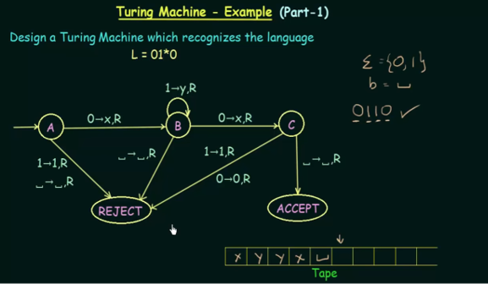

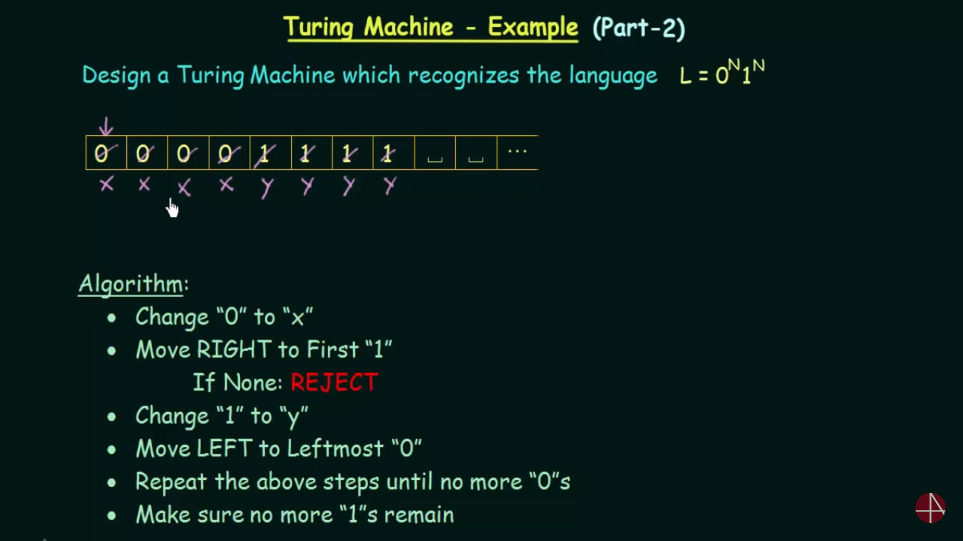  
found 1 extra 0 (i.e 5th 0, change to x and search for 1. If that 1 is not present then reject. There-fore **n(0)!=n(1)**

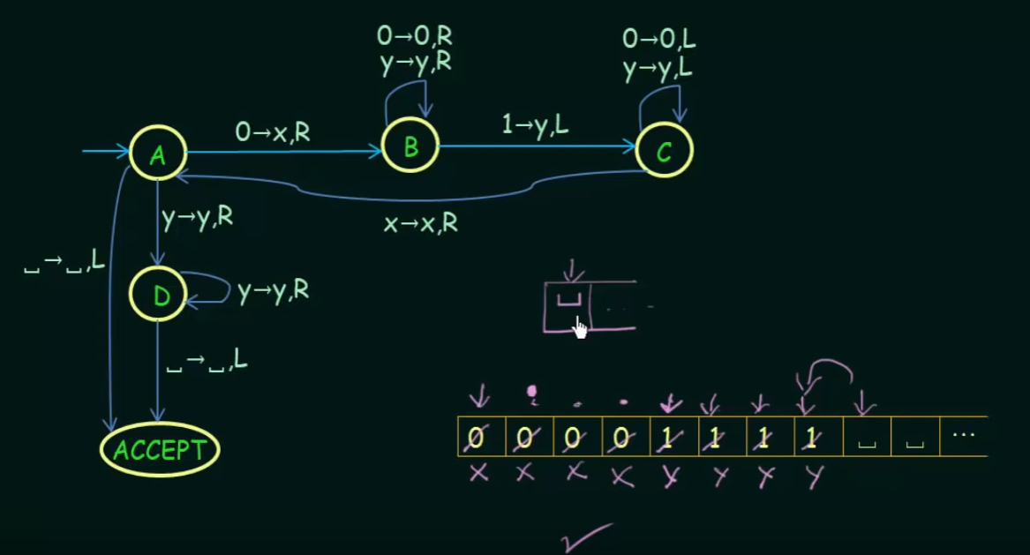

Hint:   
After replacing all the strings(i.e 1 and 0) with x’s and y’s. Simply pass the states with x’s and y’s, if all the strings are exactly replaced by x and y, then your turing machine is correct for the given condition.

Design a Turing Machine that accepts the   
L={a*}  
L = {a^+}  
L = {a^n b^n | n>=1 }

**Question  
L = {a^n b^n c^n | n>=1 }**

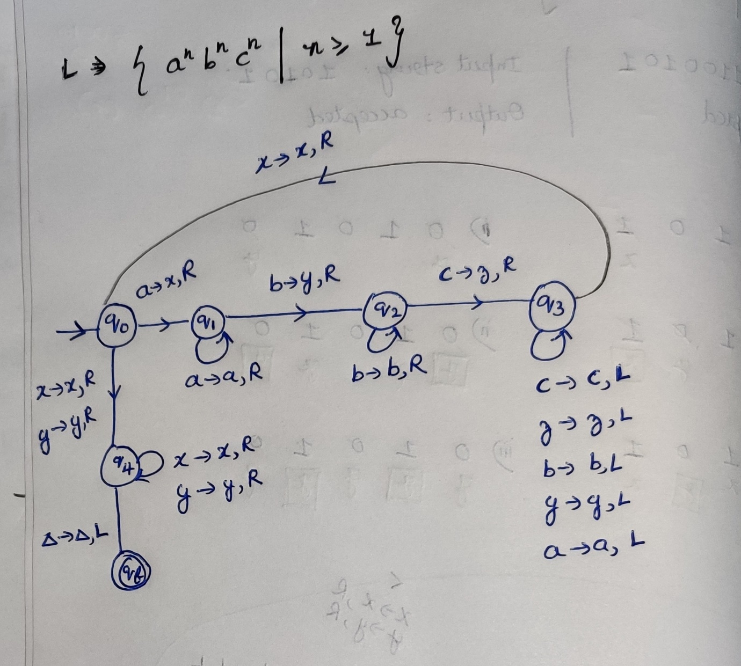

**Question  
L = { ww^r | w belongs (0,1) }**  
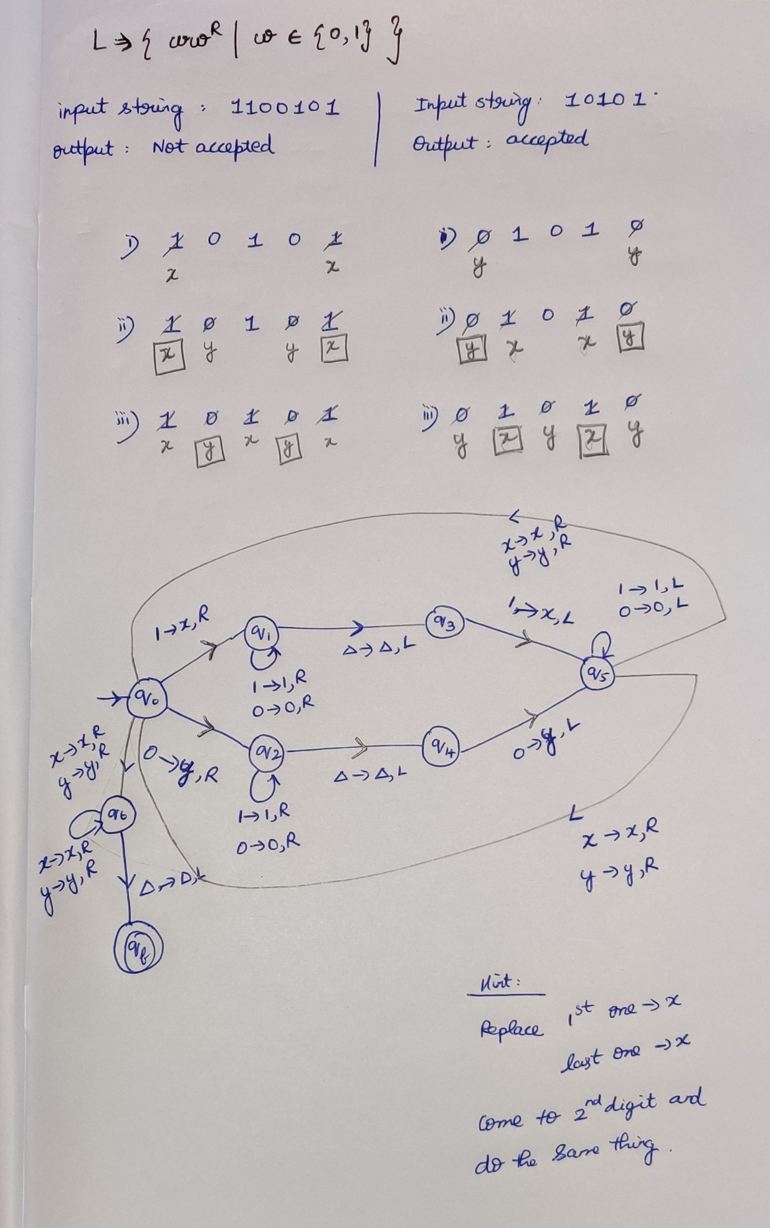

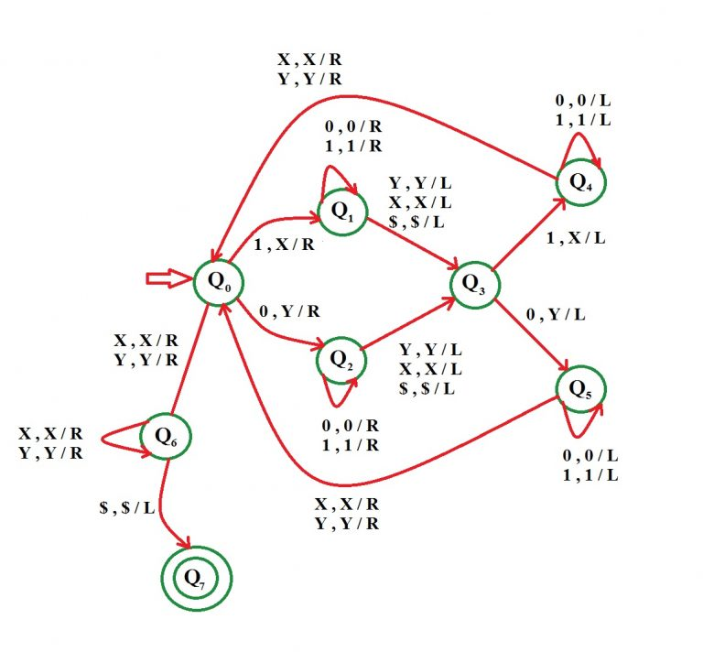

**Question**L = { n(a)=n(b) | w belongs (0,1) }

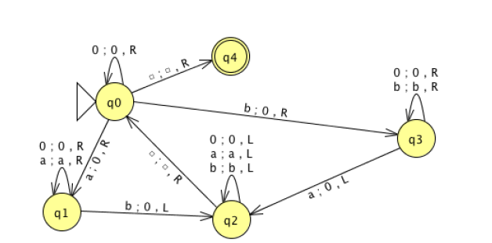

**Question**L = { a^n b^m a^(n+m)| n,m>=1 }  
<https://www.geeksforgeeks.org/construct-turing-machine-l-bm-anm-nm%e2%89%a51/?ref=rp>

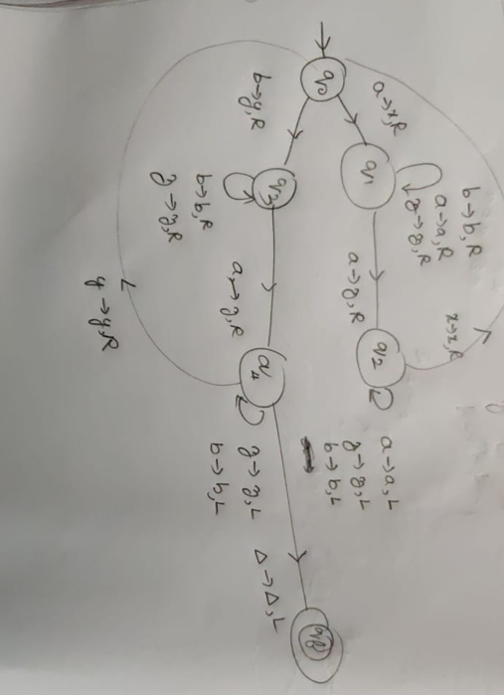

**Question  
L = { 0^2n 1^n | n>=0 }**

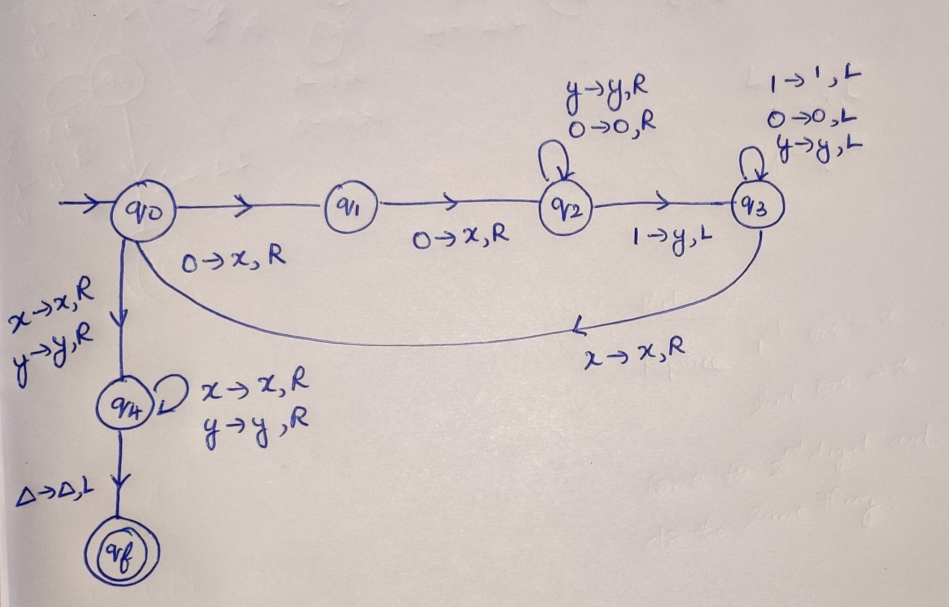  
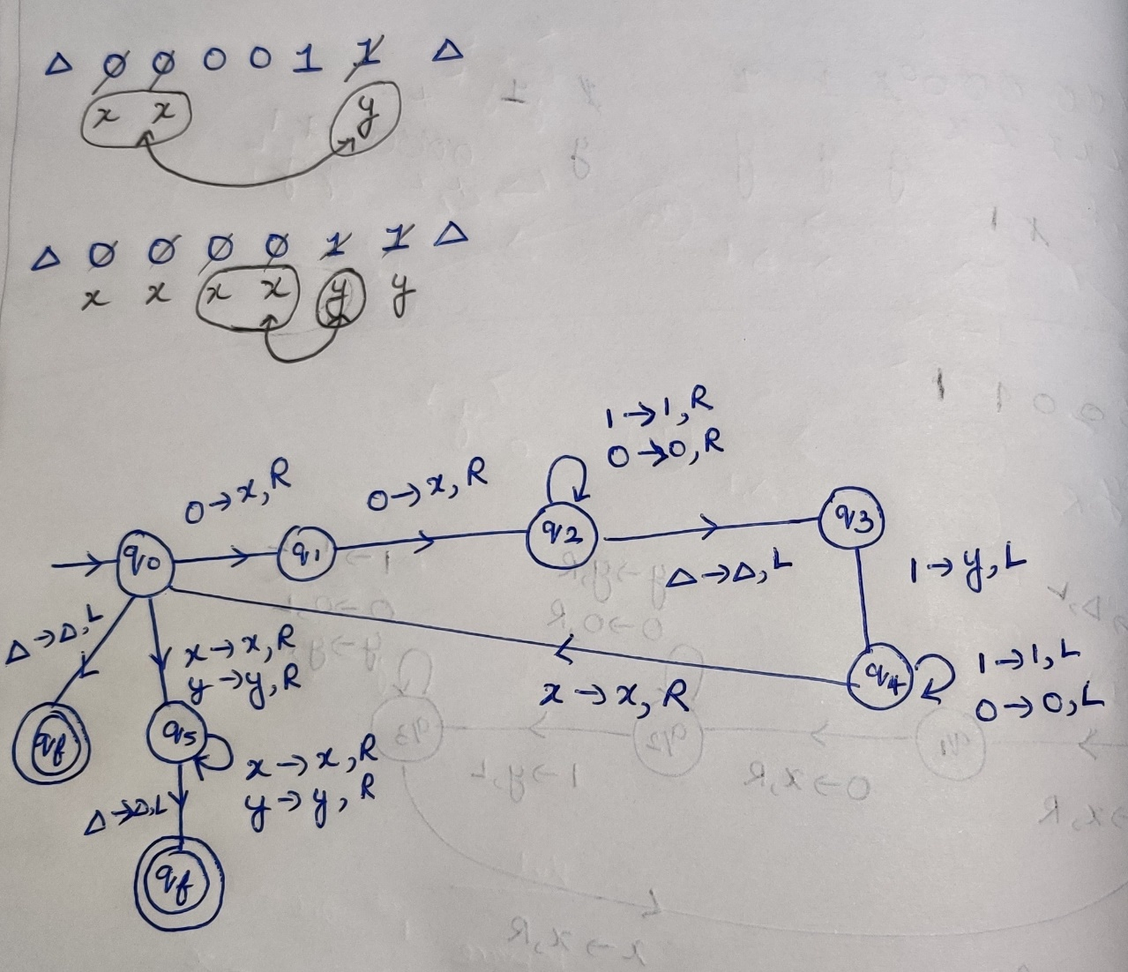

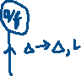

**Turing Machine as a computing device**

Design a turing machine for concatenating two strings  
w1.w2=w  
w1 🡪 11111  
w2 🡪 1111

Design a turing machine for x+1

Design a turing machine for x+3

**Question  
*Design a Turing machine for 1’s complement***

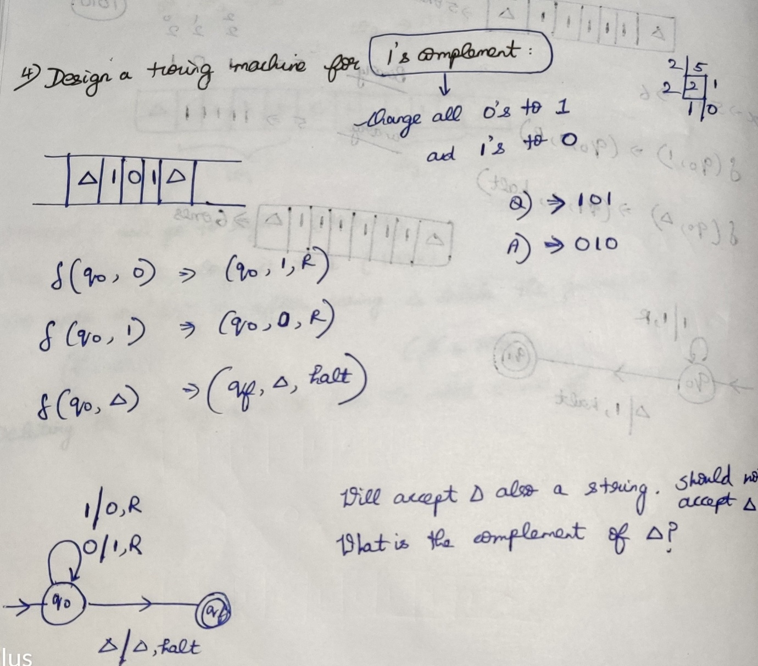

What is wrong ??  
With no input, only accepting the blank input it will go to the final state.  
There is no complement for the blank symbol.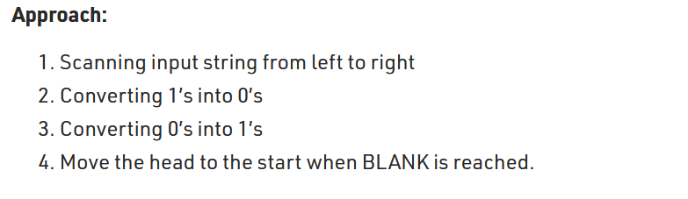  
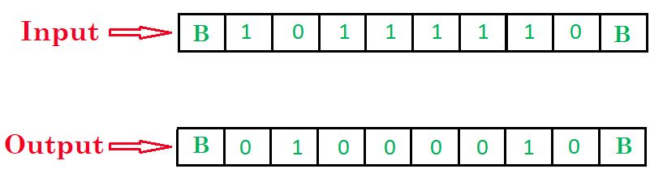  
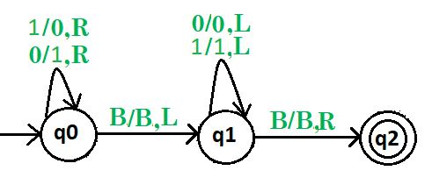  
After traversing all the symbols(left to right) definitely traverse it once again(right to left) and keep the cursor at the first position of the string .

**Question  
*Design a Turing machine for 2’s complement***

(12) 1100 🡪 0100  
(13) 1101 🡪 0011  
(18) 10010 🡪 01110  
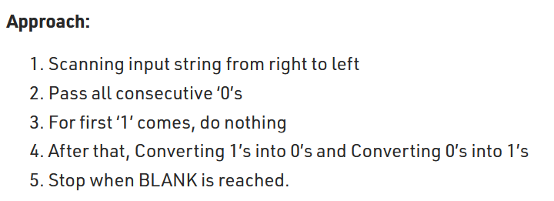  
  
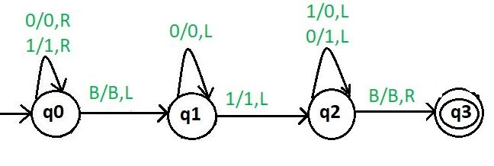  
After traversing all the symbols(left to right) definitely traverse it once again(right to left) and keep the cursor at the first position of the string

***Turing machine for addition(Unary representation of a number)***

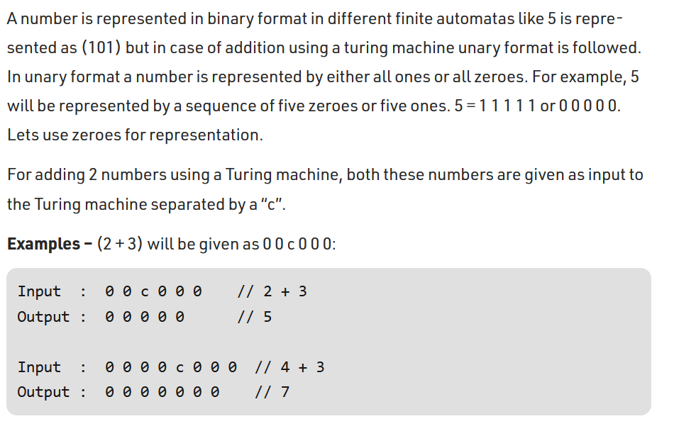  
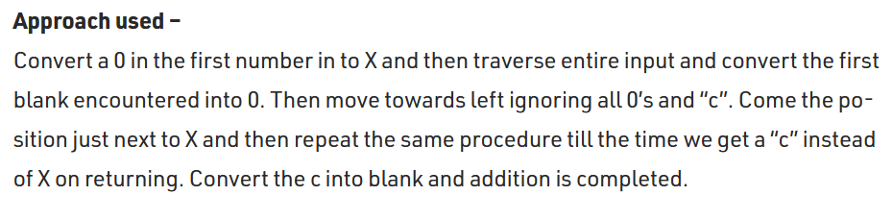

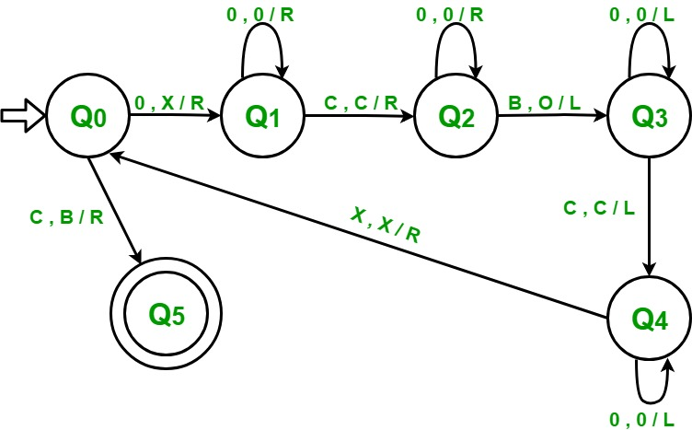

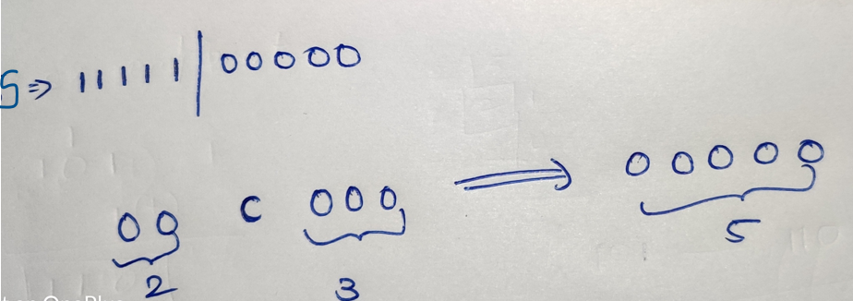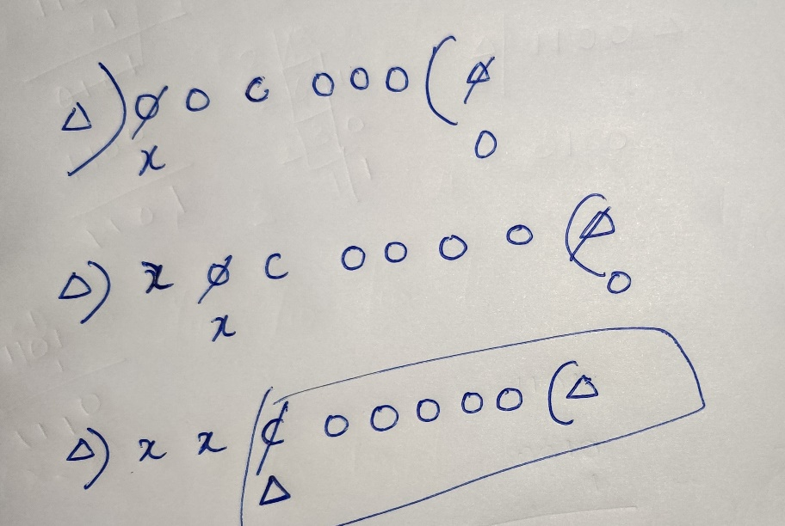

***Turing machine for subtraction(Unary representation of a number)***

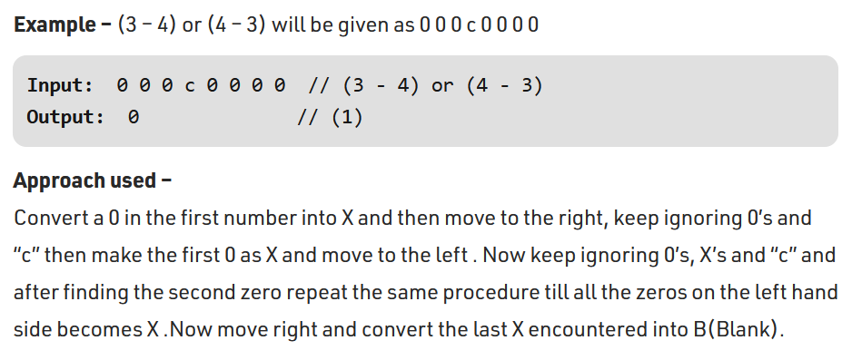

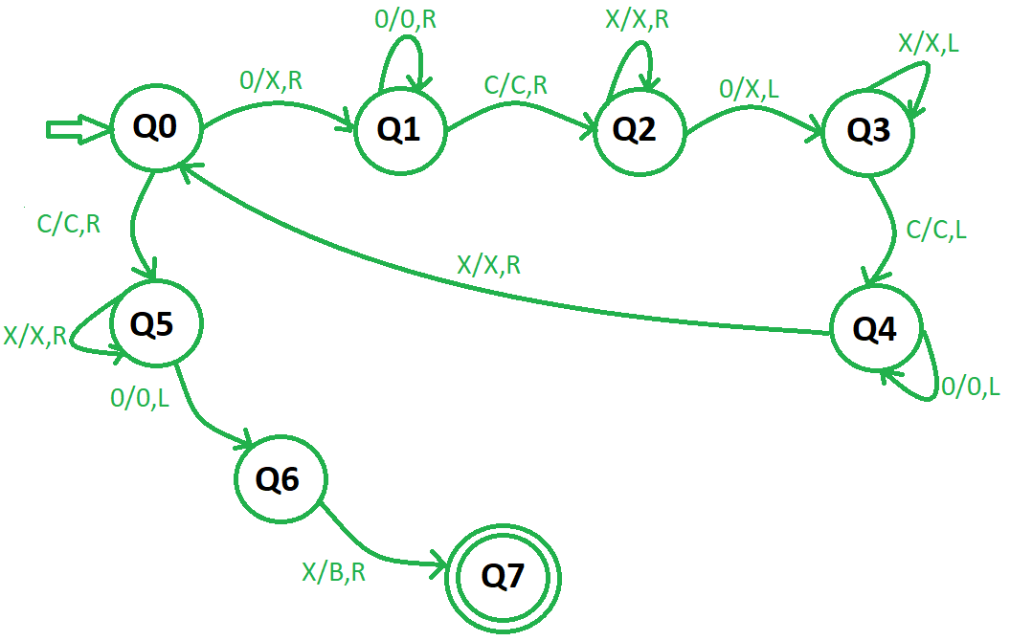

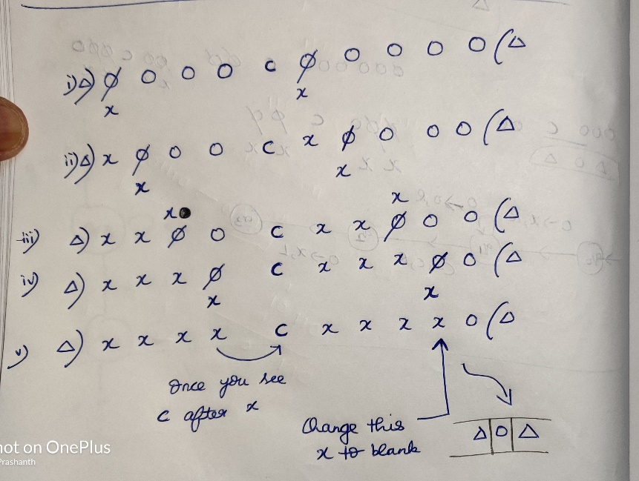

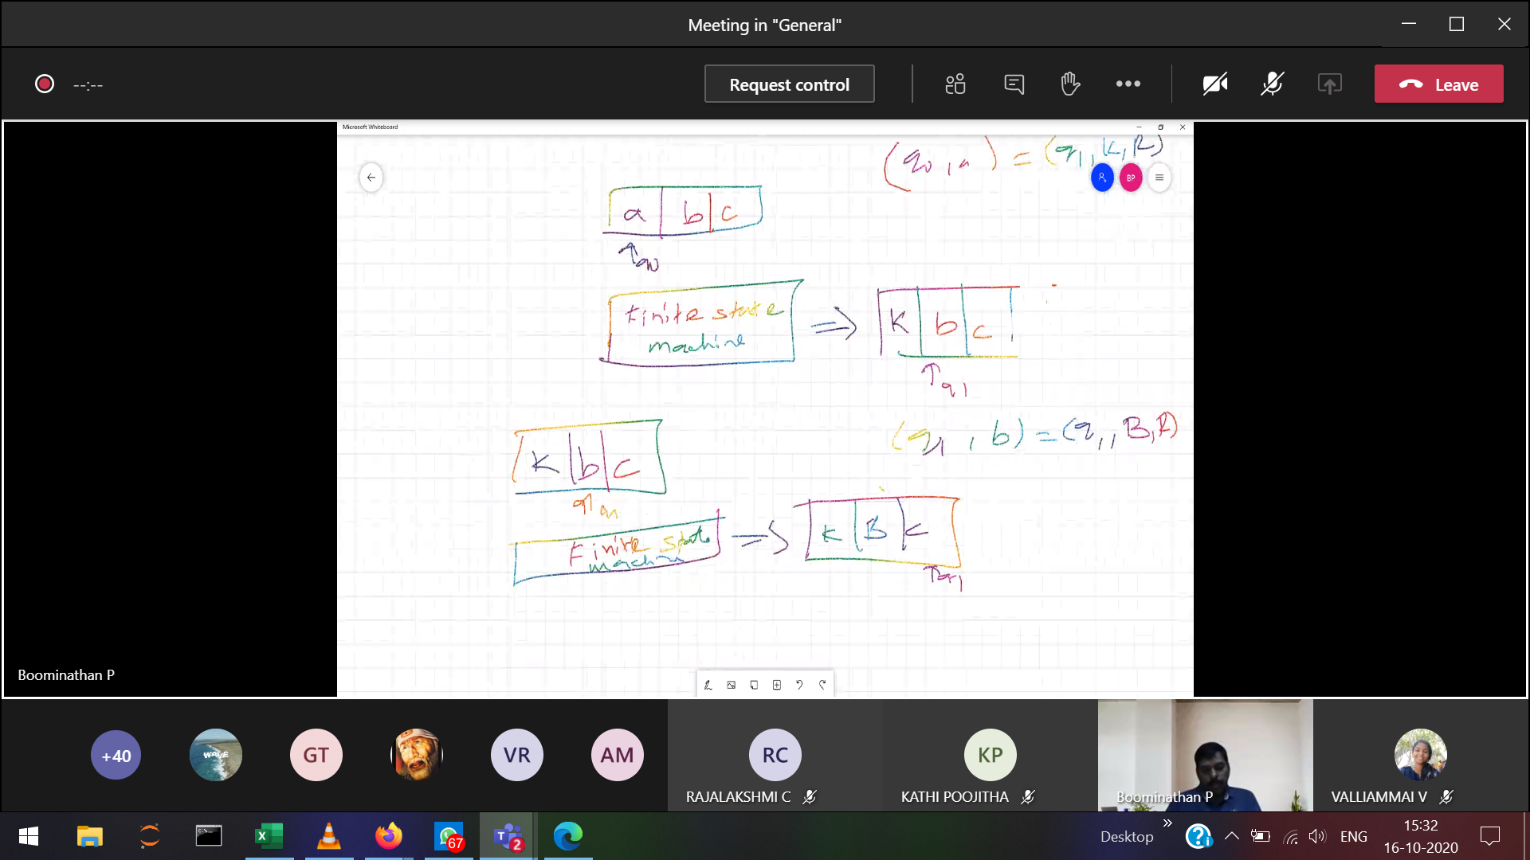

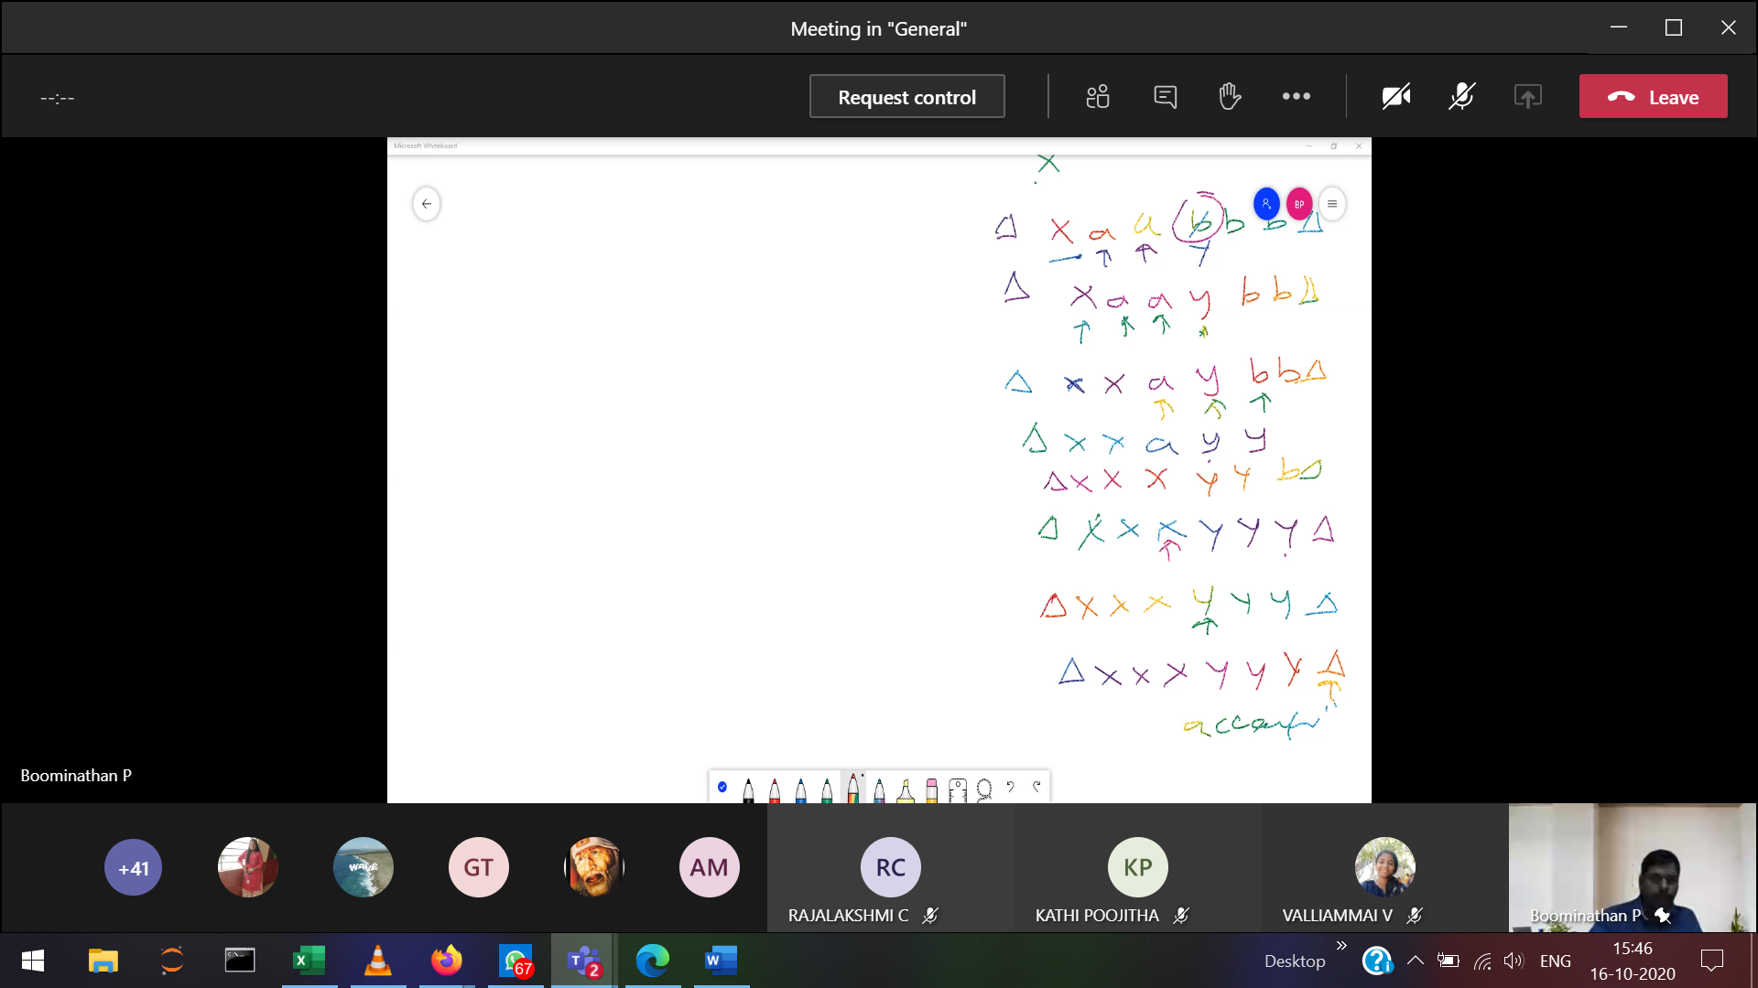

Instantaneous Description